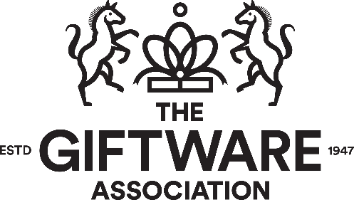

The GIFTWARE ASSOCIATION
Notice of Meeting

NOTICE is hereby given that the Annual General Meeting of Members will be held at Federation House, 10 Vyse Street, Hockley, Birmingham, B18 6LT on Wednesday 8th May at 11am for the purpose of:

ORDINARY BUSINESS

- Receiving notice of the appointment by the National Committee of Mr Mark Jones as Chair of the association for the period 2024/25.

- Receiving notice of the appointment by the National Committee of Louise Welsby as Deputy Chair of the association for the period 2024/25.

- Receiving notice of the appointment by the National Committee of Stephen Illingworth as Vice Chair of the association for the period 2024/25

- Receiving notice of the appointment by The National Committee of Daniel Fagan as a committee member of the association for the period 2024/26.

- Re – electing Tabi Marsh as a committee member for the association for the period of 2024/26.
- Re – electing Therese Ortenblad as a committee member for the association for the period of 2024/26
- Re – electing Zoe Bonser as a committee member for the association for the period of 2024/26
- Re – electing Alex Ryan as a committee member for the association for the period of 2024/26
- Re – electing Sangat Chandhok as a committee member for the association for the period of 2024/26

Dated this Tuesday 16th April 2024 By Order of the Board
Registered Office
Federation House
10 Vyse Street Natalie Edmead-McKie
Birmingham, B18 6LT Company Secretary

NOTE: A Member entitled to attend and vote at this meeting is entitled to appoint a proxy to attend and vote in his/her stead. A proxy need not also be a Member.

